April 10th, 2011
Hi
Little to write about. Tuesday was a holiday, though I did not know at first what it was for. Turned out to be for the Ching Ming (spring grave-sweeping) festival. Of course, there were the usual hill fires due to people lighting fires carelessly near grave sites. I think there were only about 40, which is quite a lot fewer than at other times.
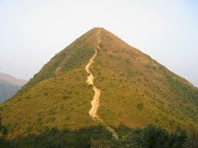
The run yesterday was quite exhausting. At about 22-23⁰C, it was not too hot but it was very humid. I went up Needle Hill in the Shing Mun reservoir area; I don't know if any of you have been up this hill but it is quite steep, hence its name. A 2 h 52 min, the run was longer than I had anticipated as the route was not exactly the same as for past runs. Very tired in afternoon.
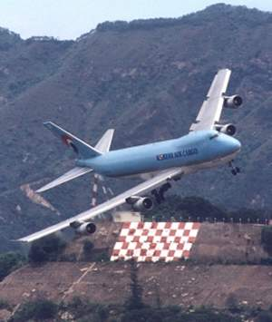
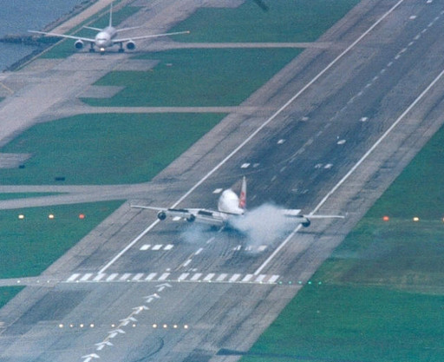
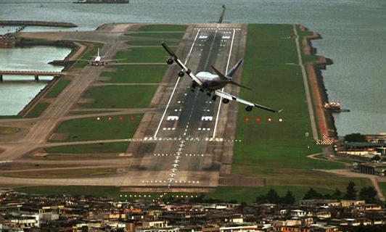
BTW, when I was searching for a picture of Needle Hill, I came across these pictures of planes landing at the old Kai Tak airport from the land approach where planes had to approach low over the buildings and then make a sharp 90⁰ turn with only a few hundred metres before touching down on the runway. Although an extremely dangerous approach, there were never any serious accidents though there were a few close calls. I actually enjoyed this landing as you could look out the window and see the people on the streets below. Can any of you remember landing using this approach? Have a look at these videos for interesting landings:
http://www.youtube.com/watch?v=OtnL4KYVtDE
From cockpit:
http://www.youtube.com/watch?v=lx3Ccs5tKfw
The old Kai Tak runway is being converted into a cruise ship terminal and will be ready in a couple of years.
From my comment last week about mainland mothers coming to HK to give birth. The government has now not making such appointments until the end of the year.
That’s about it for now. Not much this time.
Cheers

